Case study 2: Descartes, chef de secte?
1. Introduction
The rejection of Aristotelian thought is generally considered to be one of the central characteristics of the so-called Scientific Revolution. René Descartes’ mechanical philosophy offered an alternative to the philosophy of the schools. ‘Descartes’s enormous ambition’, says Peter Dear, ‘led him to dream of replacing Aristotle as the master of philosophy.’ Supposedly to isolate himself, Descartes moved to the Netherlands in 1628. In the end, however, the philosopher created his own ‘sect’. This case study addresses the following questions:
1. To what degree is Descartes’ ‘enormous ambition’ evident from the letters?
2. Did his contemporaries also understand his aims in this way?
3. Is it possible to trace and visualize the spread of Descartes’ thought and reputation?
2. Searching for Aristotle and Descartes
Aristotle and Descartes were frequently mentioned together in letters (see the first case study). These letters can be isolated by searching for:
Aristot* AND *cartes* => 26 results.
Q1: Cartes is also French for cards. Is this a reliable wildcard? Why (not)?
This gives the following visualisation of the correspondent network:

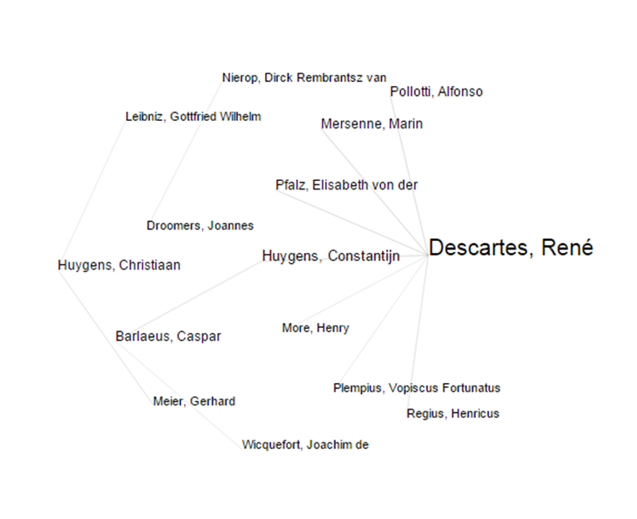
Figure 1: correspondent network for Aristot* en *cartes*.
The image shows three separate networks. The correspondence of Christiaan Huygens, Dirck Rembrantsz van Nierop and René Descartes.
Q2: come up with several reasons why it cannot be concluded that these networks are truly separate.
Interesting is the connecting line from Descartes via Constantijn Huygens to Caspar Barlaeus and Joachim de Wiquefort. Constantijn Huygens formed a link between more natural philosophical and humanist/philological circles (see case study one).

Figure 2: cocitation index Aristot* AND *cartes*. No threshold.
The cocitation index revolves around the triangle Voetius-Aristotle-Descartes. The presence of Voetius is perhaps most striking. In itself this is not remarkable. He was Descartes’ biggest enemy in the Netherlands. But he is absent from the correspondent network. Actors in the network wrote a lot about, but not with Voetius. This suggests that absence in the correspondent network and prominence in the cocitation index is an indication of gossip, group formation and exclusion mechanisms. In the case of royalty or deceased persons the absence from the correspondent network will obviously have other reasons.
3. To what degree is Descartes’ ambition evident from the letters?
Introductory texts often speak of the aim of a certain author or the meaning of a certain philosophy. If you look at the matter in more detail, history proves to be more complicated. Historian of science, James Secord has argued that science should be treated as a form of communicative action. The question of ‘what’ is being said cannot be answered independently of the ‘how’, ‘where’, ‘when’ and ‘to whom’?
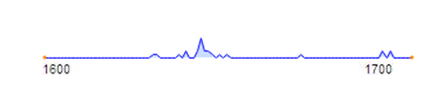
Figure 3: timeline.
Most letters from the result list were written between 1641 and 1645. But the first letter dates from 1629, and was written by Descartes and addressed to Mersenne. (It is not the first letter from Descartes to Mersenne.) This is relevant in two respects. First, it suggests that the connection Aristotle-Descartes can be traced to Descartes himself. It was not introduced by others. Second, Mersenne was a central node in the Republic of Letters. His role in the correspondence on natural philosophy can only be compared to Henry Oldenburg.
In this letter, Descartes complains that theology has been connected so strongly to Aristotle, ‘qu'il est presque impossible d'expliquer une autre Philosophie, sans qu'elle semble d'abord contre la Foi.’ Probably to avoid conflict with religious authorities, he asks Mersenne for the Church’s position on empty space and the (in)finitude of the universe. He doesn’t say much about his own position. In a later letter, Descartes would recall Galileo’s fate.
Mersenne’s role as a source of information, also shows from the second letter:
Je vous remercie des qualités que vous avez tirées d'Aristote; j'en avais déjà fait une autre plus grande liste, partie tirée de Verulamio [Francis Bacon], partie de ma tête, et c'est une des premières choses que je tâcherai d'expliquer, et cela ne sera pas si difficile qu'on pourrait croire; car, les fondements étant posés, elles suivent d'elles-mêmes.
This broaches another issue. Qualities play a central role in Aristotle’s philosophy. Colour, taste, gravity and levity exist according to Aristotle. They can only inhere in substances, but they are real nonetheless. Famous is also Aristotle’s thesis that substances allow for contrary qualities: warm/cold, wet/dry. A warm cup of tea may cool down and a wet towel can dry. This catalogue of qualities was called into question in the seventeenth century by Bacon, Galileo and, above all, Descartes. Only matter (characterized by extension) and motion exist.
The confidential relation with Mersenne becomes evident from a fascinating letter dated 28 January 1641 in which he asks him not to mention to others that his philosophy contradicts Aristotle’s:
Mais il ne le faut pas dire, s'il vous plaît; car ceux qui favorisent Aristote feraient peut-être plus de difficulté de les approuver; ct j'espère que ceux qui les liront, s'accoutumeront insensiblement à mes principes, et en reconnaîtront la vérité avant que de s'apercevoir qu'ils détruisent ceux d'Aristote.
4. Did Descartes’ contemporaries recognize his anti-Aristotelian outlook?
Vain hope. A silent revolution was not to be. This is especially due to Descartes ‘disciple’ Regius. Because he used Cartesian philosophy against Aristotle at the Utrecht University, the conflict became public knowledge. This is a significant historical moment. The contradiction may not have been completely evident from the work itself. At least, Descartes hoped so. But the battle of Utrecht of 1841-1842 would be of major consequence to the later reception of Descartes’ philosophy. The polarizing effect of the controversy created two camps. Regius was put out of his office, and became the first ‘martyr’ of the Cartesian ‘sect’.
The correspondence of Descartes shows how new converts are reported. Elisabeth von der Pfalz (1618-1680) mentions a physician who began to doubt Aristotle after reading Bacon. Descartes pushed him over the edge and made him reject Aristotle completely. According to John Heilbron the route became standard among physicians.
But not everybody could take the leap. As Von der Pfalz wrote :
C'est à cette volonté que je dois l'intelligence de vos oeuvres, qui ne sont obscures qu'à ceux qui les examinent par les principes d'Aristote, ou avec fort peu de soin, comme les plus raisonnables de nos docteurs en ce pays m'ont avoué qu'ils ne les étudiaient point, parce qu'ils sont trop vieux pour commencer une nouvelle méthode, ayant usé la force du corps et de l'esprit dans la vieille.
Historians and philosophers of science, who are familiar with the work of Thomas Kuhn, will recognize typical characteristics of scientific revolutions. New theories will initially be (mis)understood from an older paradigm. Especially the older generation will have more difficulty coming to terms with new ways of doing science, new concepts and worldviews.
Christiaan Huygens thought the decline of Aristotelianism was an entertaining spectacle. At the end of the seventeenth century, he made the following analysis. Many of the moderns still retained remnants of Aristotle’s occult qualities. Bacon developed good new methods, but had no understanding of mathematics or physics. Galileo, although he left a great deal to be done, contributed a lot to mathematical physics. Furthermore he was modest and had no ambition to become ‘chef de secte’. Descartes did. Jealous of Galileo, he wanted to create a new philosophy. Although Descartes’ philosophy failed in almost all the particulars, yet it showed the possibility of using only mechanical explanations in science. ‘Il doit estre reputè un grand esprit.’
5. Is it possible to trace and visualize the spread of Descartes’ thought and reputation?
Search for named persons Descartes. This gives 373 hits. But this search excluded terms like Cartesian. It should also be noted that searching for named persons excludes letters to and from Descartes himself. Another possibility is to search for *cartes*. This gives 821 hits, but now the results will include ‘jeux des cartes’, ‘jouer aux cartes’, etc. Not only is it too inclusive, but it is also too restrictive in the sense that it excludes Des Cartez.
Q3: can you think of a way to search that will maximize results related to Descartes, but at the same time prevent the occurrence of ‘false positives’?
Figure 4: geographical map named persons René Descartes.
From the geographical map it can safely be concluded that Descartes’ name was spread over the entire Republic of Letters. Not only did Descartes have a voluminous correspondence (figure 5), but he was also much talked of. Without exaggeration, Dirck Rembrantsz van Nierop spoke of the ‘wijtvermaerden heere R. Des Cartes’.
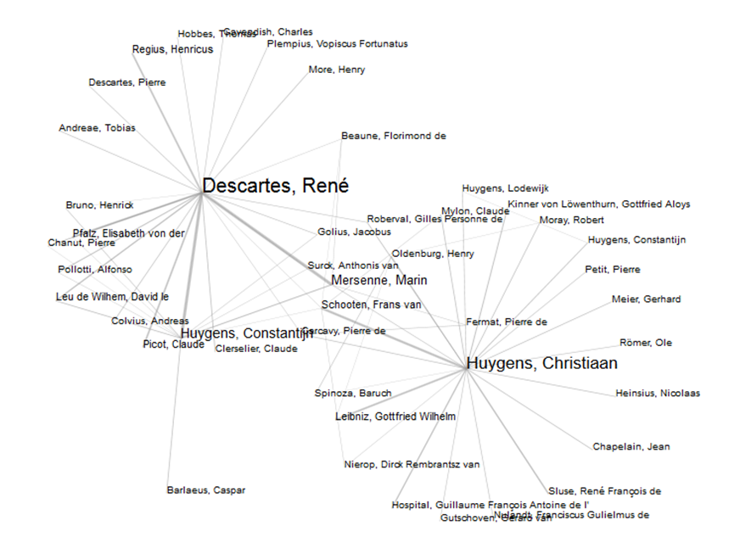
Figure 5: correspondent network *cartes*
When Descartes came to the Netherlands he did not have that much connections. Neither was he much talked of. In the next exercise you’ll reconstruct the formation of Descartes network and reputation.
Exercise: the construction of a network
So far we have not investigated developments over time. Yet it is the express intention of the ePistolarium to facilitate the study of the circulation and dissemination of knowledge in the Dutch Republic of Letters. Neither the correspondent network nor the cocitation graph gives information of developments over time.
There are various ways to investigate temporal developments with the ePistolarium. Firstly, you can scroll through the results and count. Secondly, in the upper right corner, there is small timeline where the height of peaks corresponds to the number of hits per year.
1. Why is it important to keep in mind that the corpus of the ePistolarium is not evenly spread over the seventeenth century?
Thirdly, the results can be visualized in a detailed timeline. Three lines are visible at the same time. Scales rise from month to decade to century. This visualisation is particularly useful when many letters are send in a short period. Finally, you can limit your search to a specific period. By making geographical maps, correspondence networks and cocitation graphs for successive periods, certain developments – such as the spread of an idea or reputation – can be visualized. This is the approach we’ll use in this exercise.
From 1622 to 1640 letters mentioning Descartes, or letters written to or from him, can be divided into four periods: 1622-1628, 1629-1631, 1632-1635, and 1636-1639. You can search for *cartes*.
2. For each of these four periods, use ePistolarium to draw: a geographical map, a correspondent network, and a cocitation index.
3. Comment briefly on each of these periods. Which developments do you see?
In his classic study Galileo, Courtier, Mario Biagioli has emphasized the importance of patronage networks and etiquette in the early modern period. A similar analysis may be made of Descartes’ career.
4. Study Descartes’ relationship with Constantijn Huygens from this perspective.
5. How did Descartes become the ‘wijtvermaerden heere R. Des Cartes’?
A project that is affiliated to ePistolarium is Mapping the Republic of Letters. http://republicofletters.stanford.edu/ It includes numerous beautifully visualized case studies.
6. Visit the webpage, study a few of these case studies and find at least two approaches that you could also use in the ePistolarium when investigating people like Descartes.
Another affiliated project is Cultures of Knowledge http://www.culturesofknowledge.org/ which also features an impressive catalogue http://emlo.bodleian.ox.ac.uk/ The catalogue may be used to enrich or complement your investigations in the ePistolarium.
7. Use this catalogue to find more information about the early reception of Descartes in the Republic of Letters.
5. Conclusion
In the historiography of the Scientific Revolution, Descartes’ reputation derives from his replacement of Aristotle’s teleological worldview by a mechanical worldview. The ePistolarium offers the possibility to test and further explore this image. Three questions have been addressed:
1. To what degree is Descartes’ ‘enormous ambition’ evident from the letters?
If you search for Aristot* AND *cartes* you will get 26 hits, mostly from or to Descartes in which this ambition is indeed evident. At the same time it is clear that Descartes is not ready or willing to express his anti-Aristotelian outlook in public. In a revealing letter to Mersenne he says that he hopes his readers will become converts the mechanical worldview before they realize how destructive it is to Aristotelianism. The underlying thought is that they will be less willing to go along with his reasoning, and more sceptical, when they know were the argument will ultimately lead them.
2. Did his contemporaries also understand his aims in this way?
Of course, Descartes’ immediate contacts – Mersenne, Constantijn Huygens – were well informed about his aims. But it became public knowledge, much against Descartes will, with the battle of Utrecht. It was not Descartes’ initiative but Regius who sought the confrontation. He subsequently became the first ‘martyr’ of the Cartesian ‘sect’. At the end of the century, Christiaan Huygens described Descartes as a man of enormous ambition who dreamt of becoming ‘chef de secte’. Although there is no doubt about Descartes’ anti-Aristotelian outlook, it is questionable to what degree Descartes tried to establish a school of his own. The dynamics, especially the battle of Utrecht with its polarizing effect, was beyond his control.
3. Is it possible to trace and visualize the spread of Descartes’ thought and reputation?
The most interesting question of the series has been left as an exercise for the student. By drawing maps, correspondent networks and cocitation indexes for successive periods, you can get a good picture of Descartes growing network. In this way the ePistolarium can effectively be put to use to study temporal developments.

P. Dear, Revolutionizing the Sciences. European Knowledge and Its Ambitions, 1500-1700 (Basingstoke 2001) 82.
See especially his masterly: J. Secord, Victorian Sensation. The Extraordinary Publication, Reception, and Secret Authorship of Vestiges of the Natural History of Creation (Chicago 2000).
Descartes to Mersenne 1629-12-18.
Descartes to Mersenne 1641-03-31.
Descartes to Mersenne 1630-01.
Descartes to Mersenne 1641-01-28. Emphasis added.
Regius to Descartes 1640-01, 1642-05, 1642-08. It would be interesting the further explore seventeenth-century connotations of the word sect.
Elisabeth von der Pfalz to Descartes 1647-02-21.
J. Heilbron, ‘Coming to terms with the Scientific Revolution’, European Review 15 (2007) 473-489.
Elisabeth von der Pfalz to Descartes 1644-08-01.
T. Kuhn, The Structure of Scientific Revolutions (Chicago 1962).
Correspondentie Bouilliau en Christiaan Huygens
Christiaan Huygens 1693.
The history of card games in the seventeenth century is an interesting subject in its own right. There are letters that provide insight in father-son relationships and that remind one of Polonius in Shakespeare’s Hamlet.
Dirck Rembrantsz van Nierop to Christiaan Huygens 1661-09-24. Huygens was more critical, yet he too was of the opinion that ‘Il doit estre reputè un grand esprit.’

